Living God’s Big Story Together

By the time Lucy had read to the bottom of the page, she had forgotten that she was reading at all. She was living in the story as if it were real…
“Please, Aslan,” said Lucy, “Shall I ever be able to read that story again; the one I couldn’t remember? Will you tell it to me, Aslan? O do, do, do.”
“Indeed, yes, I will tell it to you for years and years.”
C.S. Lewis, The Voyage of the Dawn Treader

The Bible is not a collection of stories-with-morals written about people long ago. Instead, the Bible tells us the grand story that we’re all a part of: a story of wonder, brokenness, hope, and redemption. It narrates the story of God’s overwhelming, never-ending, reckless love for all creation and for each of us. But that’s not all – the Bible also invites us to be a part of the story, to “read” ourselves into it as we wonder, question, live into, and live out what we’ve heard. As parents, we have the opportunity to tell this story to our children “for years and years” as they grow – and to remind ourselves of who we are and of how God’s story pulls us in.
Connect the Story to everyday life
These family devotions are meant to be a tool to help you tell God’s Big Story together as a family – not just at set times when you sit down to do “devotions,” but as you live, work, and play together. Each week includes suggested readings, questions, and activities to do together as a family – but more important than “checking” them off is to think and wonder and talk about the week’s theme as you go about normal life together. Because the Bible tells a story that includes all of us, you will certainly find connections between what you read during devotions and what you live out during the day. Talk about these together!
Choose what works for your family
The weekly schedule includes readings from both the Children’s Storybook Bible and Scripture references to read with a standard translation (child-friendly versions include NLT, NIV, NIrV, and The Message). Depending on the age and attention span of your children, you could use just one or both options – or read the Scripture yourself and read the Storybook Bible to your children. I also plan to post a video each week giving a longer overview to the theme of the Big Story “chapter” of the week.
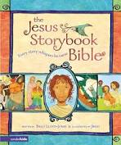

Invitation to Wonder…
Whether you’re reading a children’s Bible or a “real” Bible, your reading time should provide an opportunity to wonder together as a family. Read with pauses and end each reading with the question, “What do you wonder about after hearing this?” Be aware of your own wonderings, too, and voice them – seeing you engage will help your children feel freer to ask their own questions. Don’t feel like you need to answer all the questions! Often, it is sitting with our own questions and wonderings that engages and transforms us the most – and your children may remember the wonderings and questions better than they will remember your answers.
Praying the Psalms
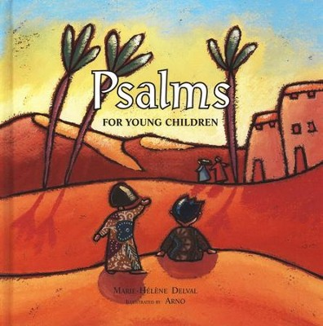

For thousands of years, both ancient Israel and the church have prayed the Psalms to express every emotion imaginable to God: joy, despair, anger, praise, contentment, sorrow, guilt, fear, and gratitude. Psalms for Young Children is a book that presents Psalms in simple language, without avoiding some of the “heavier” emotions. Even very young children feel regret, sadness, and fear, and this book gives them an opportunity to acknowledge and voice those feelings to the God who hears, cares, and responds.
Although I schedule particular psalms each week, they are only suggestions. I encourage you to read through all the psalms in this book and lead your child in reading (or saying) them as a prayer at appropriate times. For example, Psalms 4 and 63 are lovely to say together before going to sleep; Psalm 85 or 32 when a child is racked with guilt; Psalm 69 in sadness, and Psalms 70 and 46 in fear. When I was little, I found myself repeating snatches of the Psalms in times of fear and anxiety and joy – this book offers children words to do the same.

